Trent Giever

Debbie Wolf

CS 140

1/2/19

Connecting Server and Workstation

Server IPv4 Address: 172.22.17.30

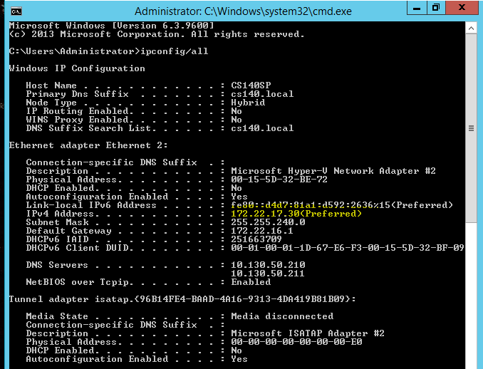

Workstation IPv4 Address: 172.22.17.31

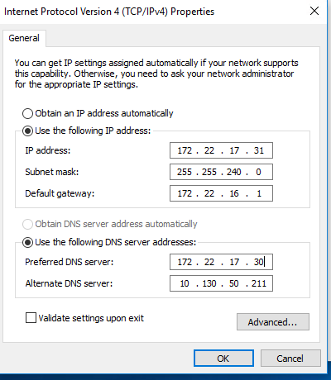

Welcome to the domain screenshot

